Sachin G Poojary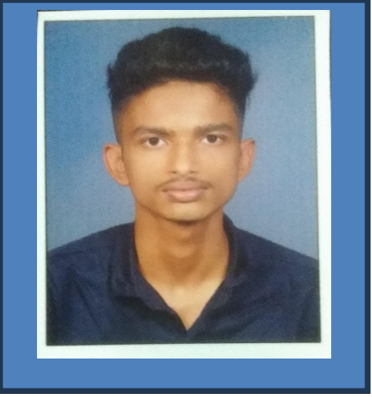

# Address:

Haradi ,Salikeri Post

Bhramavara Tq. Udupi District 576213.

**Email:**

# [sachingpoojary2004@gmail.com](mailto:sachingpoojary2004@gmail.com)

# Phone:

+91 8660339460 (7795292558)

# Career Objectives:

To work in a creative and challenging Environment with dedication, sincerity and professionalisms where I could constantly learn and sharpen my all-round skills leading to prosperity of the organization.

# Academic Background:

| **Qualification** | **Passing Year** | **Institution** | **Marks in %** |
| --- | --- | --- | --- |
| Diploma in Computer Science | Pursuing | Govt. Polytechnic Udupi | 1st Sem CGPA: 7.78  2nd Sem CGPA: 8.50  3rd Sem CGPA: 8.82  4th Sem CGPA: 9.00 |
| P.U.C | 2022 | SMS PU College Bhramavara | 84.83% |
| S.S.L.C | 2020 | SMS College Bhramavara | 72.16% |

# Skills:

* Attentive listener.
* Good Communication Skills.
* Quick Learner.
* Disciplined and hardworking.

# Programing Language known:

# 

# Hobbies:

Creativity, Playing games, Drawing

# Personal Profile:

Date of Birth : 27/05/2004

Nationality : Indian

Status : Single

Languages Known : English, Hindi, Kannada

# Reference:

HOD Name and Mobile no

Suresh Kudalkar +91 99868 17539

I hereby confirm that all the information furnished above is true and correct. I shall show sincerity and dedication in my work, which will prove to be honest and hardworking.

Place:Udupi

Date:27/10/24

# Sachin G Poojary